Experiment 6: List Methods in Python (Add, Append, Extend & Delete)
1. Aim
To write a Python program to implement list methods such as add, append, extend, and delete.
2. Algorithm
- Start the program and initialize a list.
- Add an element to the list using insert().
- Append an element using append().
- Extend the list using extend().
- Delete an element using del and display the list after each operation.
- Stop the program.
3. Python Code
# List Methods in Python
my_list = [10, 20, 30, 40]
print("Original List:", my_list)
# Add (Insert an element)
my_list.insert(1, 15)
print("After Add:", my_list)
# Append
my_list.append(50)
print("After Append:", my_list)
# Extend
my_list.extend([60, 70])
print("After Extend:", my_list)
# Delete
del my_list[2]
print("After Delete:", my_list)

4. Output
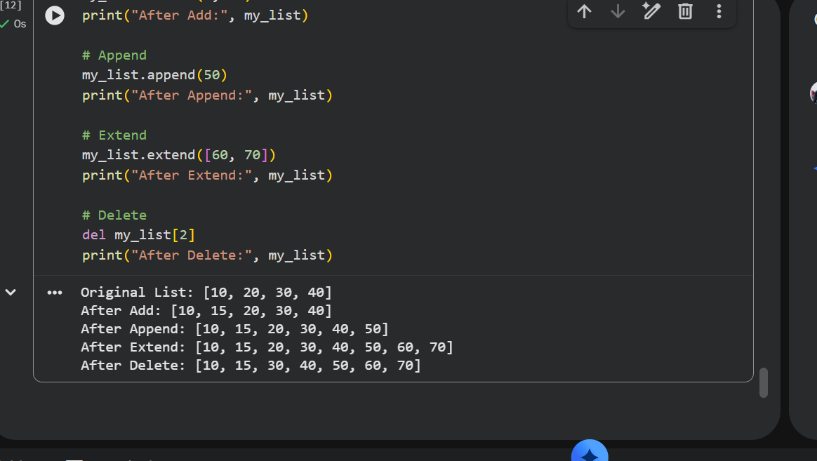

5. Result
Thus, the Python program to implement list methods such as add, append, extend, and delete was executed successfully.

Experiment 7: Different Set Operations Using Python
1. Aim
To write a Python program to illustrate different set operations such as union, intersection, difference, and symmetric difference.
2. Algorithm
- Start the program.
- Initialize two sets with elements.
- Perform the union operation to combine both sets.
- Perform the intersection and difference operations.
- Perform the symmetric difference operation and display all results.
- Stop the program.
3. Python Code
# Different Set Operations
A = {10, 20, 30, 40, 50}
B = {30, 40, 50, 60, 70}
print("Set A:", A)
print("Set B:", B)
# Union
print("Union:", A | B)
# Intersection
print("Intersection:", A & B)
# Difference
print("A - B:", A - B)
print("B - A:", B - A)
# Symmetric Difference
print("Symmetric Difference:", A ^ B)
# Membership
print("Is 20 in Set A?", 20 in A)
# Subset
print("Is A a subset of B?", A.issubset(B))

4. Output
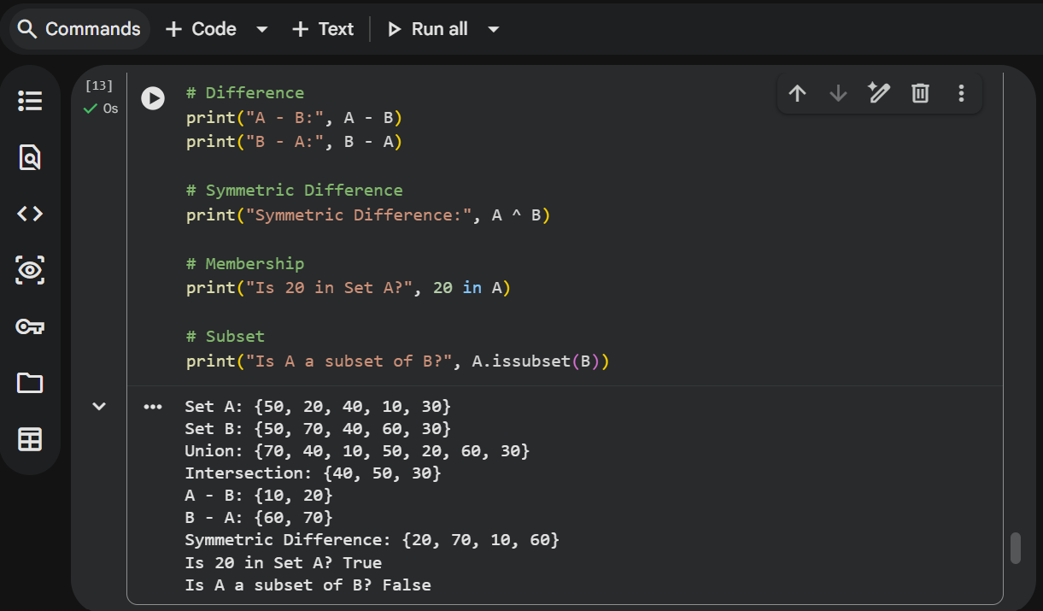

5. Result
Thus, the Python program to illustrate different set operations was executed successfully.

Experiment 8: Generate Calendar for a Given Month and Year
1. Aim
To write a Python program to generate a calendar for a given month and year.
2. Algorithm
- Start the program.
- Import the calendar module.
- Initialize the month and year.
- Generate the calendar using calendar.month().
- Display the calendar.
- Stop the program.
3. Python Code
# Calendar for a Given Month and Year
import calendar
month = 10
year = 202
print("Calendar for the given month and year:")
print(calendar.month(year, month))
4.output
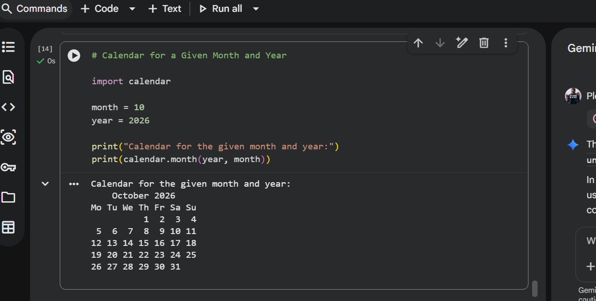
5. Result
Thus, the Python program to generate a calendar for a given month and year was executed successfully.
Experiment 9: Remove Punctuations from a Given String
1. Aim
To write a Python program to remove punctuation marks from a given string.
2. Algorithm
- Start the program.
- Import the string module.
- Initialize a string containing punctuation marks.
- Create an empty string to store the result.
- Remove punctuation marks and display the resulting string.
- Stop the program.
3. Python Code
# Remove Punctuations from a String
import string
text = "Hello, World! Welcome to Python@2026."
result = ""
for char in text:
if char not in string.punctuation:
result += char
print("Original String:", text)
print("String without Punctuation:", result)
4.output
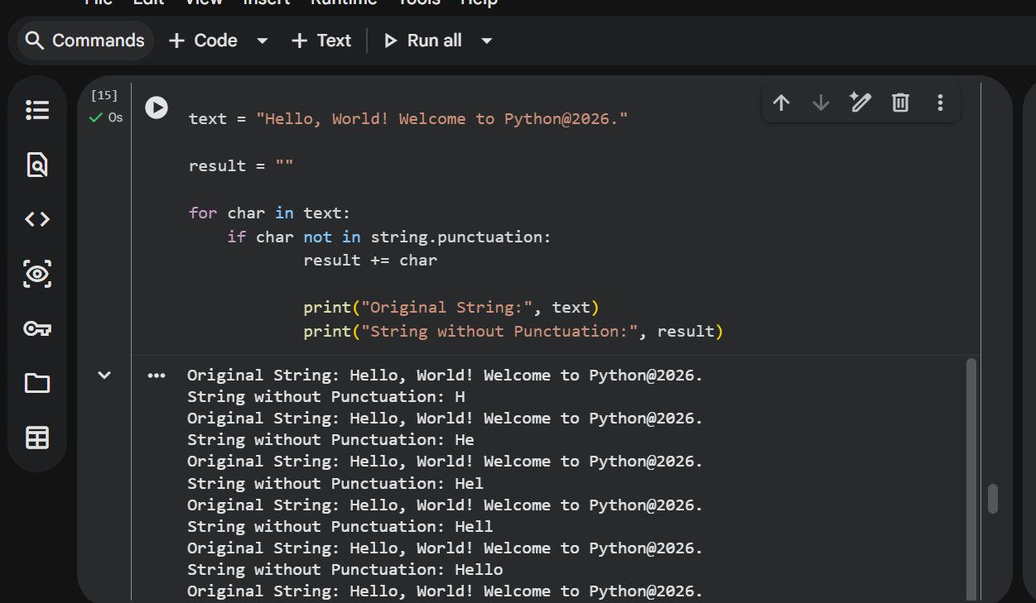
5. Result
Thus, the Python program to remove punctuation marks from a given string was executed successfully.
Experiment 10: Solve the 8-Puzzle Problem Using Python
1. Aim
To write a Python program to solve the 8-puzzle problem using the A* search algorithm.
2. Algorithm
- Start the program and initialize the initial and goal states.
- Use the A* search algorithm to explore possible puzzle states.
- Calculate the cost using \(f(n)=g(n)+h(n)\), where \(g(n)\) is the path cost and \(h(n)\) is the Manhattan distance heuristic.
- Select the state with the lowest cost.
- Generate new states by moving the blank tile in valid directions until the goal state is reached.
- Display the sequence of states and stop the program.
3. Python Code
# 8-Puzzle Problem using A* Search Algorithm
import heapq
# 0 represents the blank tile
start = (1, 2, 3,
4, 0, 6,
7, 5, 8)
goal = (1, 2, 3,
4, 5, 6,
7, 8, 0)
# Calculate Manhattan distance
def heuristic(state):
distance = 0
for i, tile in enumerate(state):
if tile != 0:
goal_index = goal.index(tile)
x1, y1 = divmod(i, 3)
x2, y2 = divmod(goal_index, 3)
distance += abs(x1 - x2) + abs(y1 - y2)
return distance
# Generate neighboring states
def get_neighbors(state):
neighbors = []
blank = state.index(0)
row, col = divmod(blank, 3)
moves = [(-1, 0), (1, 0), (0, -1), (0, 1)]
for dr, dc in moves:
new_row = row + dr
new_col = col + dc
if 0 <= new_row < 3 and 0 <= new_col < 3:
new_pos = new_row * 3 + new_col
new_state = list(state)
new_state[blank], new_state[new_pos] = (
new_state[new_pos], new_state[blank]
)
neighbors.append(tuple(new_state))
return neighbors
# A* search
def solve_puzzle(start):
priority_queue = []
heapq.heappush(priority_queue, (heuristic(start), 0, start))
parent = {start: None}
cost = {start: 0}
while priority_queue:
f, g, current = heapq.heappop(priority_queue
if current == goal:
path = []
while current is not None:
path.append(current)
current = parent[current]
return path[::-1]

if g != cost[current]:
continue
for neighbor in get_neighbors(current):
new_cost = g + 1
if neighbor not in cost or new_cost < cost[neighbor]:
cost[neighbor] = new_cost
parent[neighbor] = current
priority = new_cost + heuristic(neighbor)
heapq.heappush(
priority_queue,
(priority, new_cost, neighbor)
)
return None
print(state[i:i+3])
print("\nTotal moves:", len(solution) - 1)
else:
print("No solution found.")
4. output
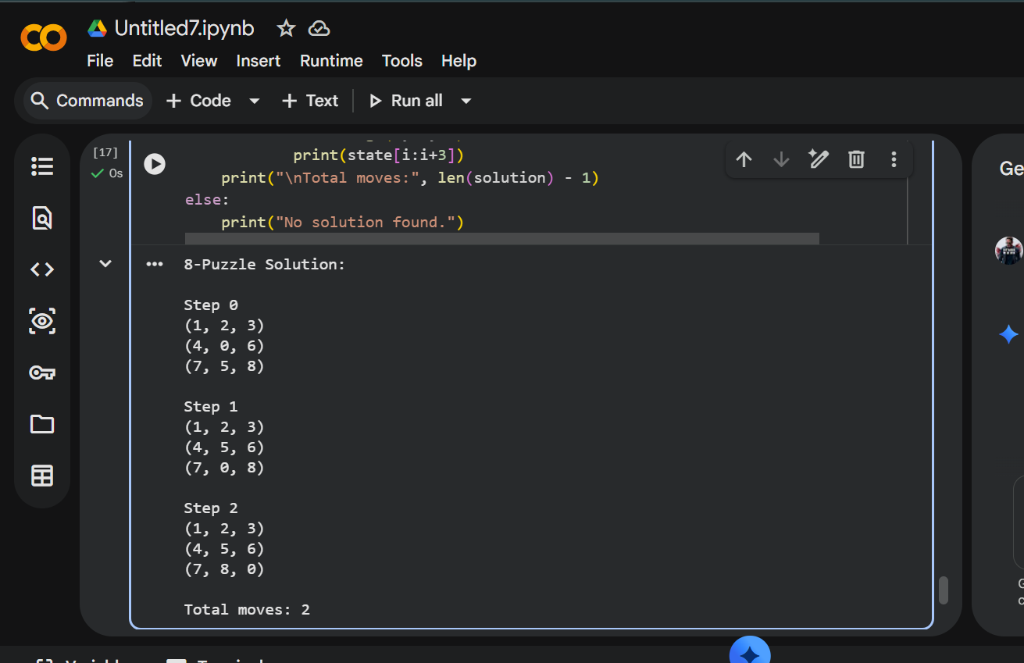

5. Result
Thus, the Python program to solve the 8-puzzle problem using the A* search algorithm was executed successfully, reaching the goal state in 2 moves.

